James 1 Study Sheet
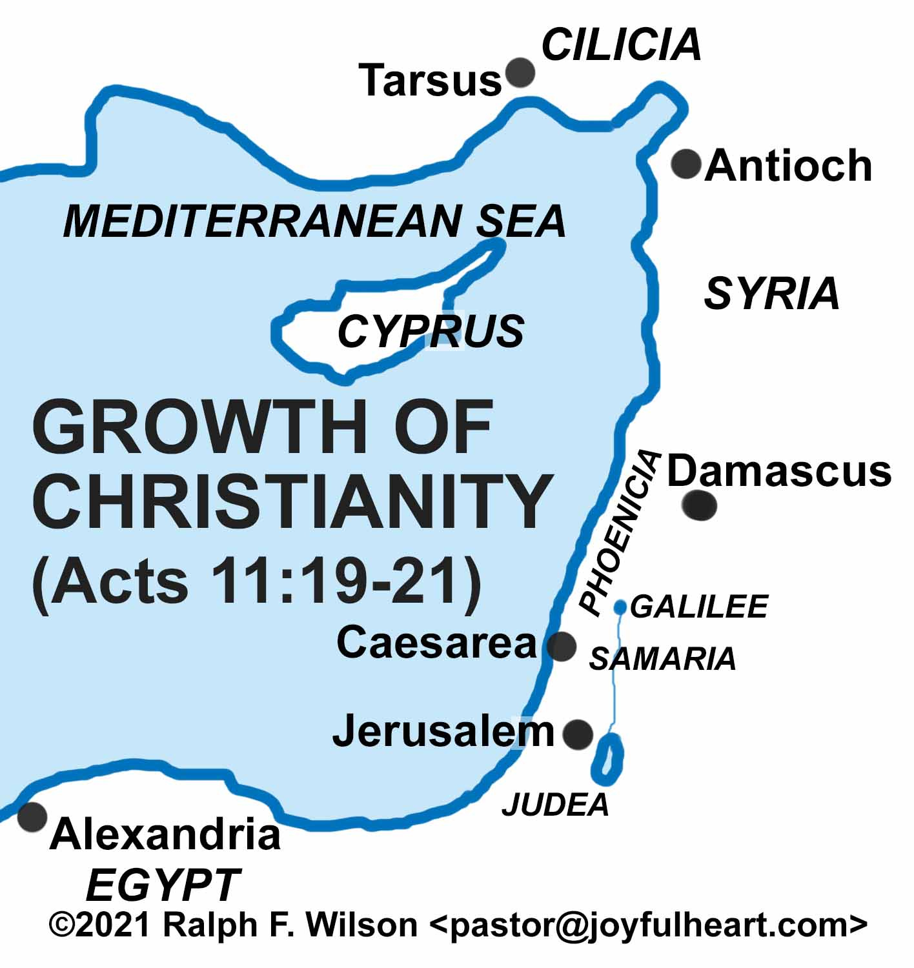
1.James wrote his letter to the “Twelve Tribes of the Dispersion.” A great persecution after the martyrdom of Stephen caused the Jewish Christians of the Jerusalem church to run for their lives. Circle the locations where these Jewish Christians fled.
(Acts 8:1; 11:19)

2.James 1:2-4 - Think about someone you know who has been steadfast in their walk throughout many life trials and thus has become mature in character.

3.James 1: 5 - What does Solomon say in the Book of Proverbs about wisdom?
Proverbs 2: 1-5 - How does one find wisdom?

Proverbs 3:13-18 – What are some blessings to those who find wisdom?

4.Contrast God’s character with that of the doubting man in verses 5-8.
God | Doubting Man

5.What are the rewards of remaining steadfast in faith (V. 4, 12)?

6.The penalty of sin of any kind or extent is spiritual death.
- Trace the steps in verses 14 and 15 that lead to spiritual (and often physical) death.

- What Biblical example(s) demonstrate(s) this progression?

7.What do you think James meant when he referred to God as “the Father of Lights”?

8.According to verses 26-27, what are three areas where religion (faith) should be put into action?
a.

b.

c.

Faith in Action Challenge for James 1 – Practice sanctification this week by being “quick to listen and slow to speak” in one conversation each day. Make a note of how you did and be ready to share your experience next week in class.

during Trials and in Service

