Mark 11: Holy Week Begins
Introduction: The Gospel of Mark, Evangelism, The Cross, Passion Week
Philippians 2:5-8
Hebrews 12:2
2 Corinthians 5:21
- Does Jesus know what is going to happen to Him? Mark 8:31; 9:31; 10:33-34

- Why Jerusalem? Psalm 87:1-3

“God Himself established Zion or Jerusalem as the center of worship. He ordained Solomon to build a temple there so that He could live among the Israelites (1 King 6:13). Zion is holy because of God’s declaration (1 Kings 11:13), His promise, the worship given Him there (1 Kings 8:14-66), the future work of the Savior there (Matthew 21:4-11), and the future rule of the King there (Revelation 21).”

Sunday: Mark 11:1-11 Triumphal Entry into Jerusalem, Donkey, Palm Branches
Zechariah 9:9
Psalm 118: 25-26
Notes:
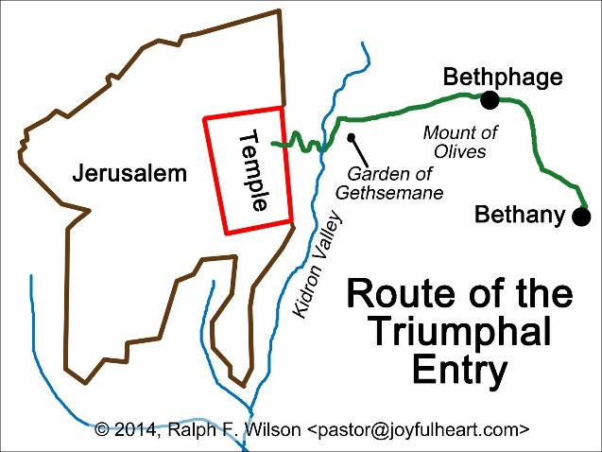
- What does “Hosanna” mean?
Monday: Mark 11:12-19 Fig Tree Cursed, Temple Cleansed
- Why was the fig tree cursed?

- In what way was the Temple cleansed?

- What is the Temple’s original design? Exodus 25:8; 1 Kings 8:10-11

Tuesday: Mark 11: 20-33 Teaching about Faith and Forgiveness, Authority Questioned
- What was Jesus’ response to the disciples when they saw the fig tree withered?
Mark 11: 22
This is an immediate fulfillment to what Jesus had said. This is an object lesson to teach the disciples that Jesus does what He says. Therefore, all the other things He has previously said will come to pass.
The mountain has multiple meanings. To a human, it is impossible to move a mountain. But with faith in God, impossible situations become possible. The second meaning is that “removing mountains” is an idiom for “overcoming seemingly unsurmountable difficulties and problems”.
- What are the main messages in Mark 11:22-33?

When Jesus is confronted by the Scribes and Pharisees who question His authority, Jesus responds with a question of His own to them about “The Baptism of John”.
- What is the “Baptism of John” and why was that so important? Mark 1:1-11.
Isaiah 40:3
Malachi 3:1
- Question for reflection: What did Jesus accomplish at the cross?

Conclusion: Prayer

New King James Version Study Bible. Second Edition. Earl D. Radmacher, Th.D., General Editor. (Thomas Nelson: Nashville, 2014.) Note Psalm 87:1, p. 919.
Lamsa, George M. Idioms in the Bible Explained and A Key to the Original Gospels. (Harper and Row: San Francisco, 1931, 1971, 1985). Entry for removing mountains- Matthew 21:21, p. 54.

