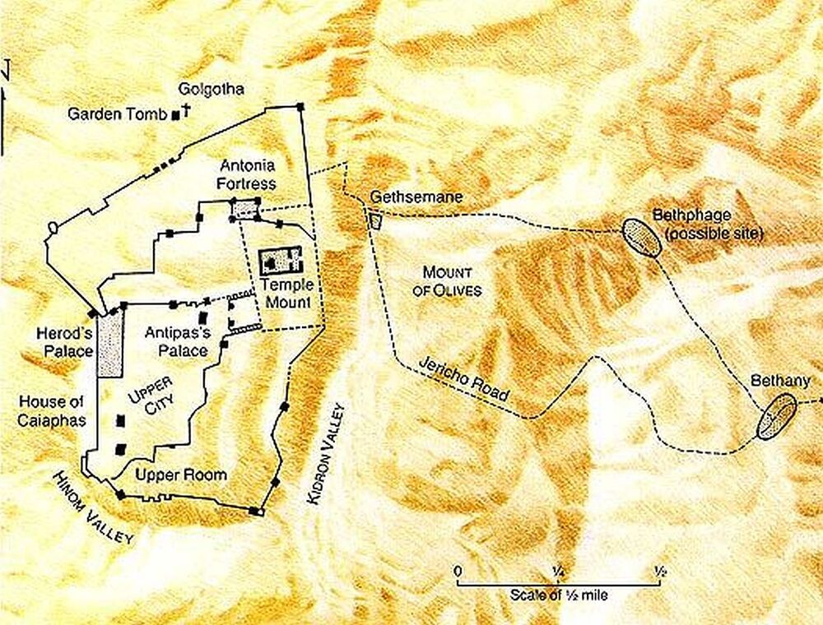
During Passover Week, Jesus and his disciples spent their nights in Bethany, some two miles walking-distance east of Jerusalem. They probably stayed in the home of Lazarus, Martha, and Mary. On Thursday night, after the Passover Feast, he and his twelve disciples planned to spend the night in the Garden of Gethsemane because Jews were required during Passover to stay in Jerusalem.

- On the map, number in order the locations where Jesus finds himself in Mark 14: 1) Mount of Olives, 2) House of Caiaphas 3) Upper Room, 4) Bethany, 5) Gethsemane (Matt. 26:57)

- In this same Passover Feast account (v. 12-16), Jesus tells the disciples in Luke 22:14-15 that he has earnestly desired to eat the Passover with them before he suffered. Why do you think he particularly desired to eat this Passover feast with the disciples?

- There are times when God, in his sovereignty, simultaneously affirms the order of events in history and yet affirms human responsibility for those events. For example, in Genesis 50:18-21, Joseph tells his brothers, “You meant evil against me, but God meant it for good to bring it about that many people should be kept alive, as they are today.” Although God’s good plan was the result, Joseph’s brothers were responsible for acting on the evil in their hearts in selling Joseph into slavery.
How can our sovereign God simultaneously orchestrate Christ’s sacrificial death on the cross yet hold Judas responsible for his sins? (Mark 14:21)

- Study the chart below. Consider the difference between the traditional Passover Supper with the newly instituted Lord’s Supper.
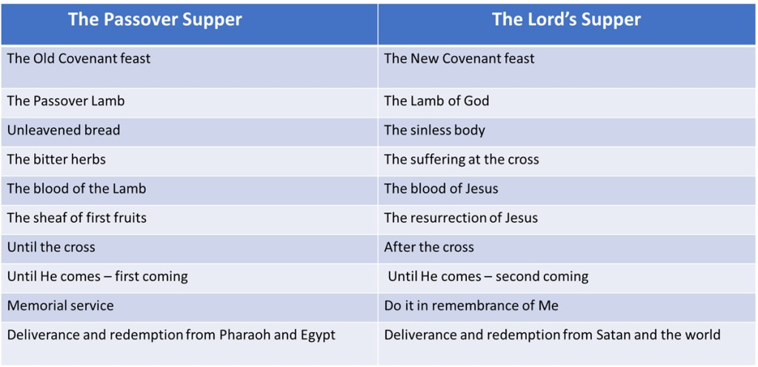

- When reading the parallel account of the arrest of Jesus in the Garden of Gethsemane in John 18:11, Jesus tells Peter, “Put your sword into its sheath…”
- What sorts of emotions and thoughts do you think Peter and the other disciples had when Jesus told them to not fight? Why did they feel and think that way?

- Instead, what action did the disciples take?

- Earlier in the evening, what had they promised to do? (Mark 14:31)

- In Mark 14:49, why did Jesus, within the hearing of his disciples, instruct the mob that had come to arrest him to go ahead and seize him?

- In verse 62, how does Jesus affirmatively respond through prophecy to the high priest that he is the Christ, the Son of the Blessed.

Psalm 110:1 (Mark 12:35-37)
Daniel 7:13-14

Mark 14 Highlight: From Extravagant Love to Hostile Hate

